
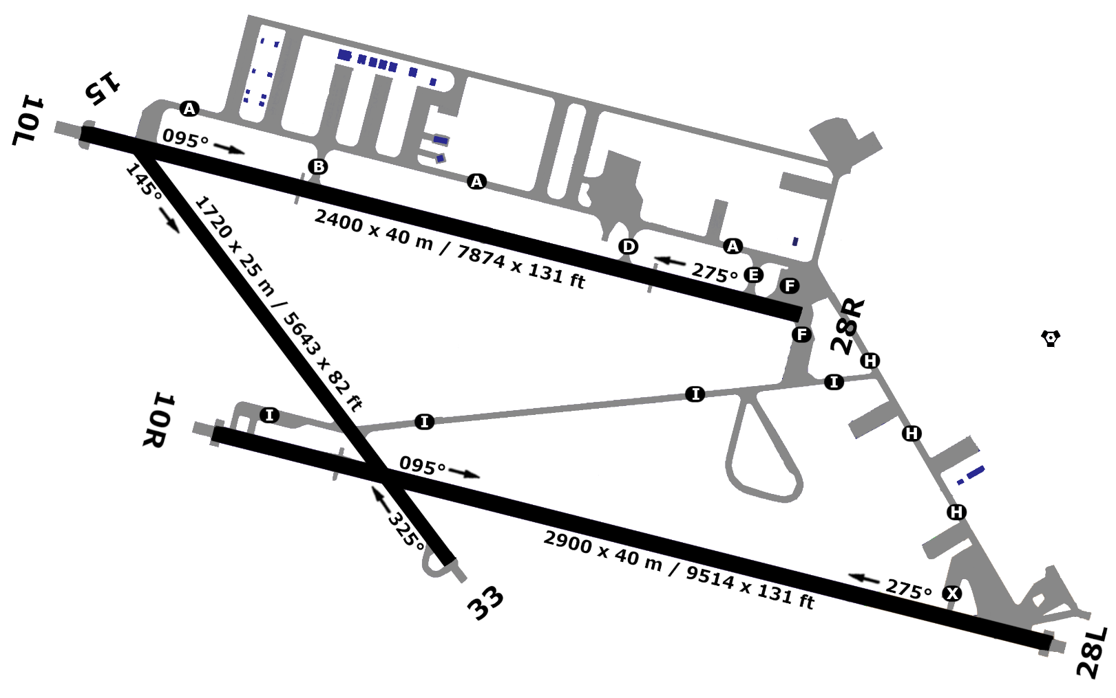
96X
LLHB - HATZERIM
28L1
10R
28R
10L
685 ft
685 ft
685 ft
685 ft
685 ft
685 ft
1.0
2400 m
2400 m
2900 m
2900 m
1720 m
1720 m
33
15
31°14”08’N
34°40”10’E
1.0

